**Other Teaching Qualifications: new functionality**

The requirement is for teachers whose Membership Type = **“Other Teacher”** (i.e. not “IYTA Teacher”) to upload evidence of their qualifications, so that anyone viewing that person’s profile can see that they have a legitimate yoga teaching qualification, in order to be included in the “Find a Teacher” table.

This change will entail changes to several forms, and will require new fields in the database.

**1. Admin form**

This form is only viewable by those with Admin access – currently the Website Administrator and Membership Secretary.

If Membership Type = “IYTA Teacher” or “Other Teacher”:  
-> Display a text field **“Yoga Qualification”** and allow updating  
-> Display a button that allows an image or PDF of the qualification to be uploaded.

Both fields are NOT mandatory.

*Also is this functionality possible?*

If Membership Type = “Teacher Trainee”  
 AND Membership Type is updated to “IYTA Teacher”  
-> Populate the text field **“Yoga Qualification”** with “IYTA Teaching Diploma Course”.

**2. Find a Teacher profile form**

This form displays when a user selects a teacher from the “Find a Teacher” table. Only teachers who are active members and have given approval to be listed on the website are displayed in the table.

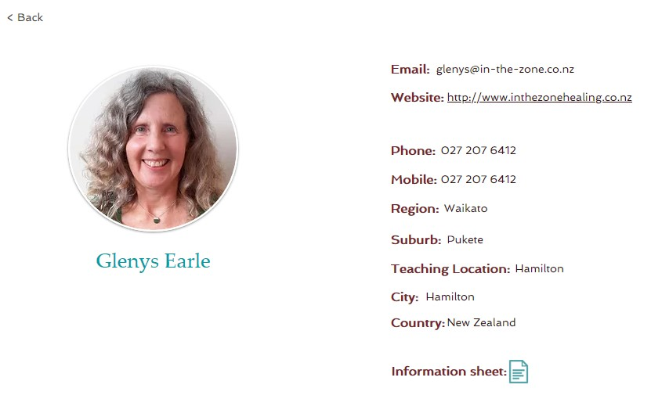

If the member’s Membership Type = “IYTA Teacher” or “Other Teacher”:  
-> Display the text field **“Yoga Qualification”**  
-> Display an icon that allows the user to select the qualification file if it has been uploaded; otherwise the icon does not appear.

*NOTE: Membership Type is not displayed.*

**3. Member profile form**

This form displays the user’s own profile. It is selected via the Profile option under the user’s name at the top right of the screen.

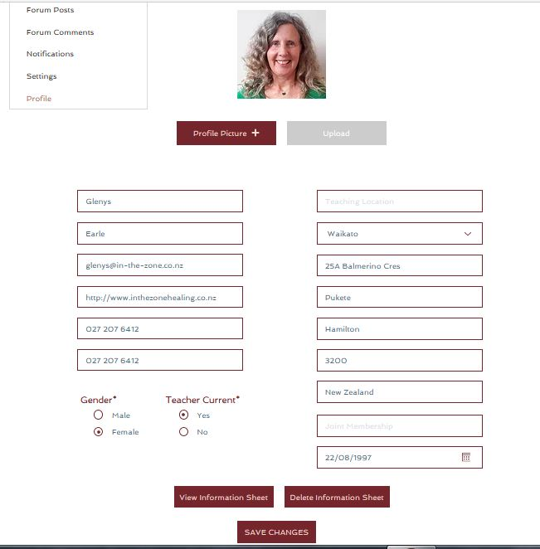

-> Display the field Membership Type (display only).

If the member’s Membership Type = “IYTA Teacher” or “Other Teacher”:  
-> Display the text field **“Yoga Qualification”** and allow updating  
-> Display a button that allows an image or PDF of the qualification to be uploaded.

*NOTE: This form does not allow the user to change their Membership Type. This can only be updated on the Admin form.*

**4. Become a Member form**

This form displays when a non member selects the option to Become a Member.

Add the following fields to the form:  
-> Display a check box **“Are you a qualified yoga teacher?”**  
-> If above box is checked, display another check box **“Did you train with IYTA?”**  
-> If 2nd box is checked, display a text field **“Yoga Qualification”** and allow updating. This field is mandatory.  
-> Also display a button to allow uploading of an image or PDF of the qualification (Not mandatory).

Function flow:

NO

**Are you a qualified yoga teacher? **

YES

**Did you train with IYTA? **

YES

NO

Set Member Type= Set Member Type=  
 **IYTA Teacher** **Other Teacher**

Populate **Yoga Qualification** field Enable **Yoga Qualification** field  
 = “IYTA Teaching Diploma Course” & upload button

*NOTE: The Membership Type is not displayed and cannot be updated by the new applicant.*

**5. Database**

There are 2 new database fields:

1. **Yoga Qualification**: text field
2. Yoga qualification image or PDF file *(is this possible to have either?)*